FAST – National University of Computer and Emerging Sciences

Theory of Automata
Assignment # 3 Deadline: 5 December 2025 Instructions:
- Attempt all questions.
- Questions must be attempted on paper (A4 sheets or loose sheets) 3.
Submit the assignment on time. Only physical submissions are accepted.
Questions 1:
Design PDA for given Context Free Language.
- To design a context free grammar which can produce balance parenthesis consider in alphabet set we have { (, )}
- Design a CFG and PDA for even and odd palindrome
  - Even palindrome 001 100
  - Odd palindrome 00100
- Design a CFG and PDA for language {01(1100)^{n} 110 (10)^{n} | n>=0}
- Design a CFG and PDA for language { o^{n} 1^{m} | n!= m}
- Design a CFG and PDA for language { (0^{n} 1^{n} 2^{m} 3^{m} | n>=1, m>=1) or ( 0^{n} 1^{m} 2^{m} 3^{n} | n>=1, m>=1) }
- Design a CFG and PDA for language { (0^{i} 1^{j} 2^{k} | k <= i, k <= j)
- Design a CFG and PDA for language { (0^{i} 1^{j} 2^{k-} | i==j, j == k}
- Design a CFG and PDA for language { (0^{n} 1^{m} 2^{2m-} | n,m>=0}
- Design a CFG and PDA for language { (0^{n} 1^{m} ⁻ | n<= m+3 }
- Design a CFG and PDA for language { (0^{n} 1^{m} ⁻ | 2^{n} <= m <= 3^{n}}
Questions 2:
Scenario-Based Question:
You are developing a syntax validation module for a simple programming language interpreter that checks nested structures like parentheses, curly braces, and square brackets.
To model this system, you are required to design a Pushdown Automaton (PDA) that verifies the correctness of balanced and properly nested symbols in program code.

Description of the Problem:
A valid program string contains balanced pairs of (), {}, and [] such that:
- Every opening symbol has a corresponding closing symbol of the same type.
- Symbols are properly nested — e.g., { [ ( ) ] } is valid but { ( ] ) } is not.
- The input alphabet Σ = { (, ), {, }, [, ] }.

FAST – National University of Computer and Emerging Sciences

Tasks:
- Define the formal 7-tuple (Q, Σ, Γ, δ, q₀, Z₀, F) of the PDA that accepts valid nested symbol strings.
- Explain the working principle of your PDA (push and pop behavior).
- Draw the state transition diagram of your PDA.
- Trace the step-by-step stack operations for the input string { [ ( ) ] }.
- Write an equivalent Context-Free Grammar (CFG) that generates the same language accepted by your PDA.

Questions 3: Turing Machines
Create Turing Machines for the following language:
  - L₁ = {0^{n}1^{m}0^{n}1^{m} |n,m≥1}.

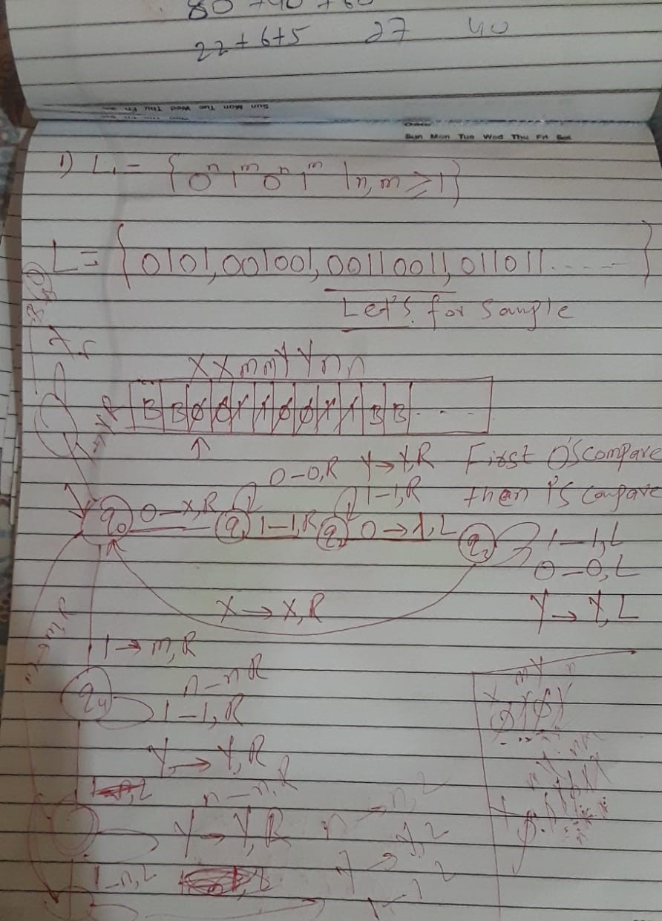

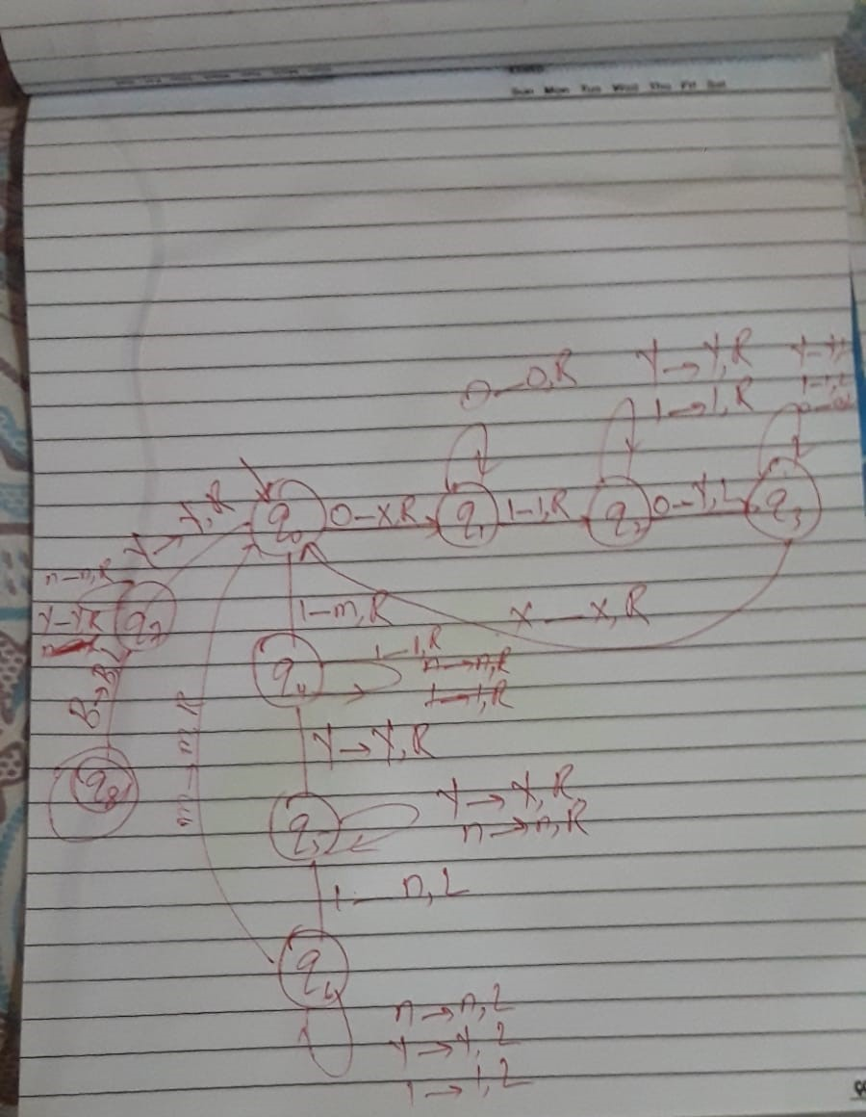

  - L₂ ={a^{3n}b^{n}c^{2n}|n≥2}. iii. L₂ ={a^{n+m}b^{n}c^{m}|n≥0}.

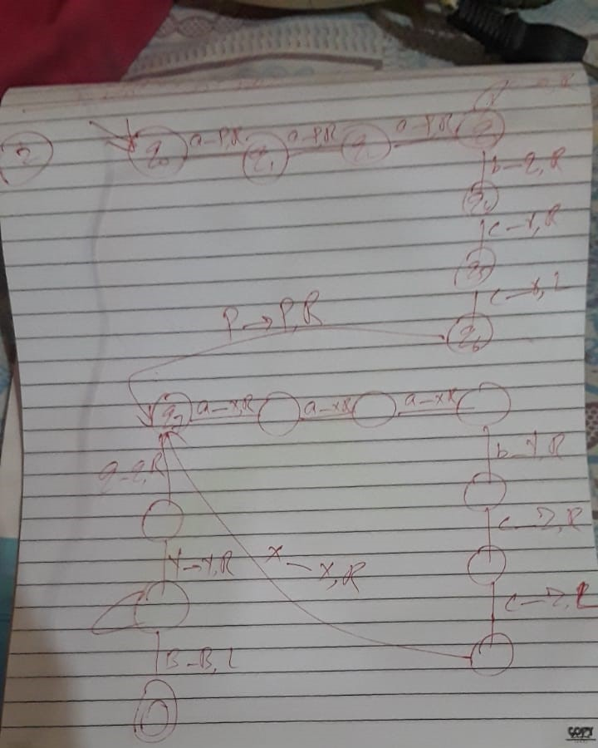
Reaming part do you self

  - L₃ = {0^{n} | n is a power of 2}

Create Turing Machines for the following function:
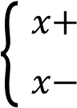
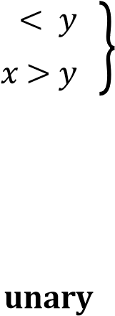
  - 𝑓(𝑥, 𝑦) = { "𝑥𝑧𝑒𝑟𝑜+𝑦 " 𝑥𝑥 <≥ 𝑦𝑦 }

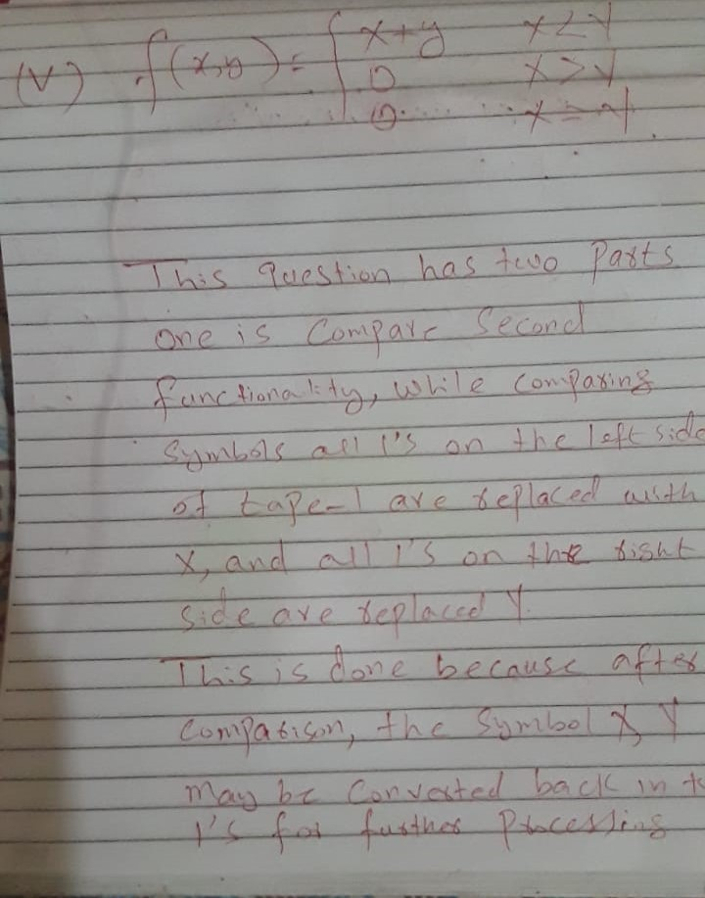
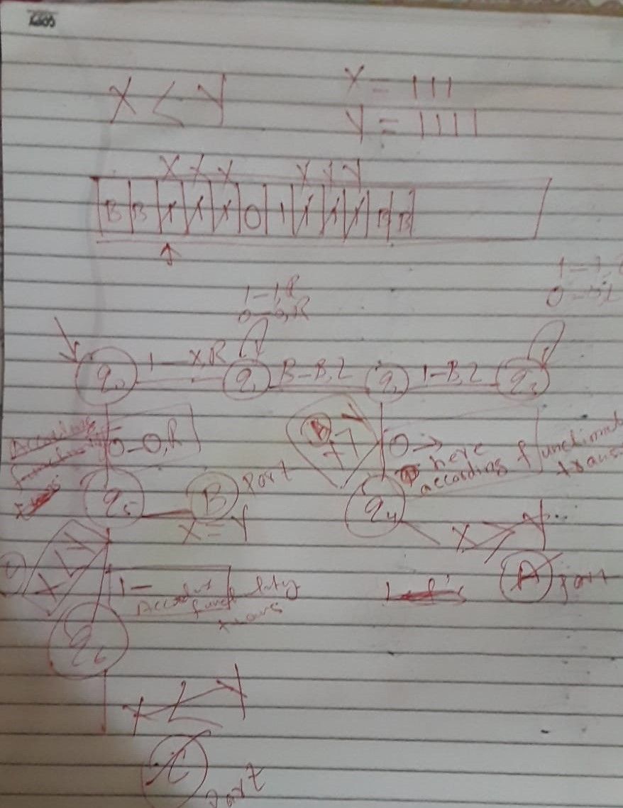
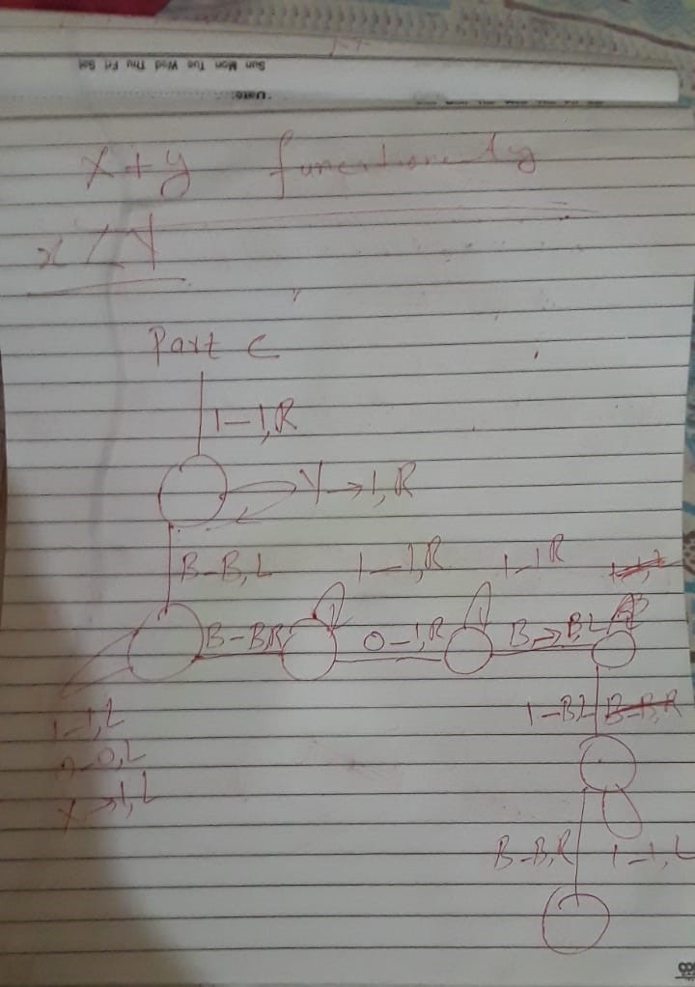

vi. 𝑦 else write "equal" on the tape
if𝑓 (x 𝑥= ,y.𝑦 ) =𝑦 𝑥
- 4^3.
- Design a TM to divide two unary numbers and output quotient + remainder.
- Design a TM to compare two numbers and output the larger one
- Modify the palindrome TM to accept only odd-length palindromes.

